XWM – MySQL

TODO

Contents

Install – MySQL on Ubuntu 2

Download Ubuntu 2

Create the virtual machine ‘xwm-mysql’ 3

Hard disk file type 3

Storage on physical disk 3

File location and size 3

Name and operating system 3

Memory size 3

Hard disk 4

Hard disk file type 4

Storage on physical hard disk 4

File location and size 5

Install Ubuntu 6

Create a Virtual Box snapshot 8

Bridge the network connection 9

Install deja-dup and do a backup 10

Remote desktop using xRDP 12

Configure the firewall for RDP 12

Remote onto xwm-mysql 13

Install MySQL 14

Create a new user on ‘xwm-mysql’ 15

Login to MySQL as admin 15

# Install – MySQL on Ubuntu

## Download Ubuntu

Download the latest version of Ubuntu,

from: https://ubuntu.com/download/desktop

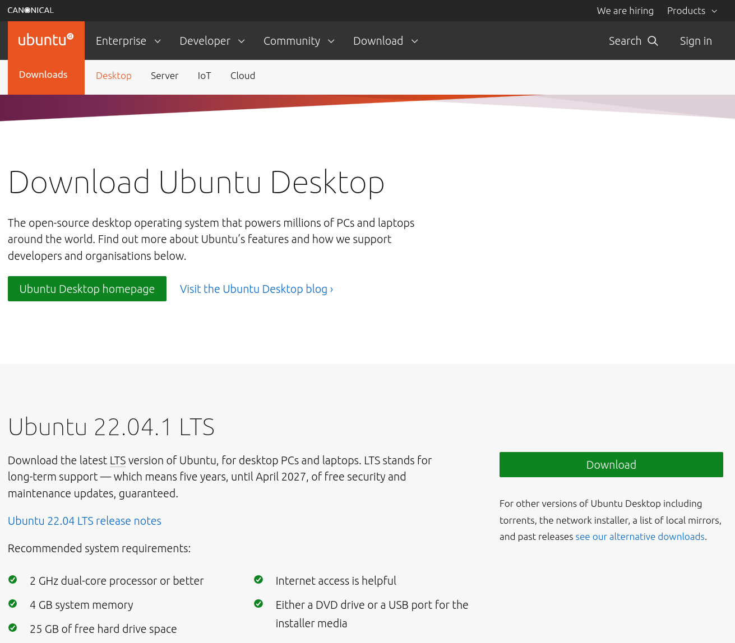

*Next, Create the virtual machine xwm-mysql …*

## Create the virtual machine ‘xwm-mysql’

To create a new Virtual Machine in Virtual Box

select: Machine > New

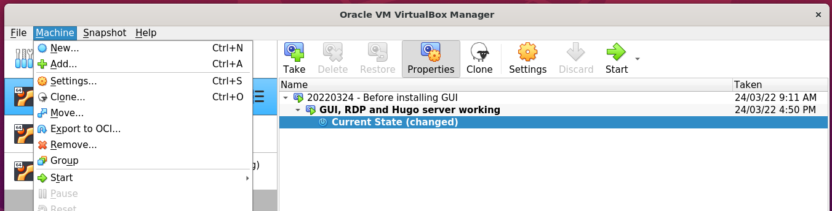

### Name and operating system

Name: xwm-mysql

Folder: /media/nath/4TB/XWM

Type: Linux

Version: Ubuntu (64-bit)

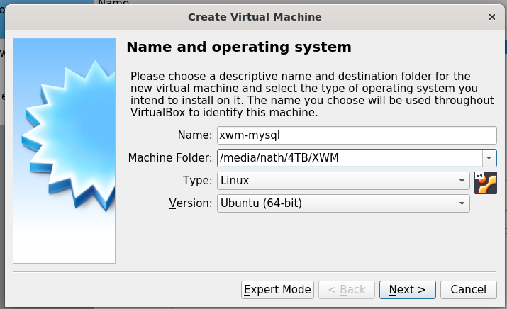

### Memory size

Select: 4096 MB

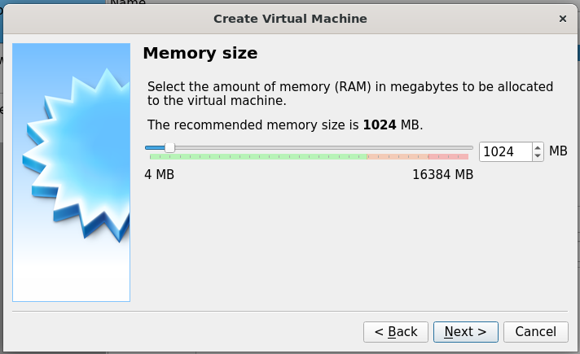

*Next, Hard disk …*

### Hard disk

Select: Create a hard disk now

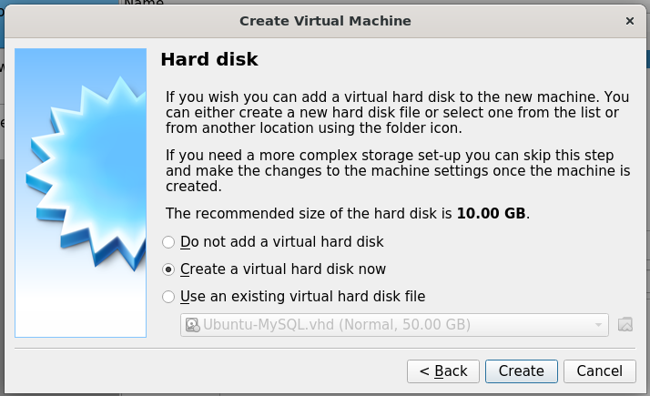

### Hard disk file type

Select: VHD (Virtual Hard Disk)

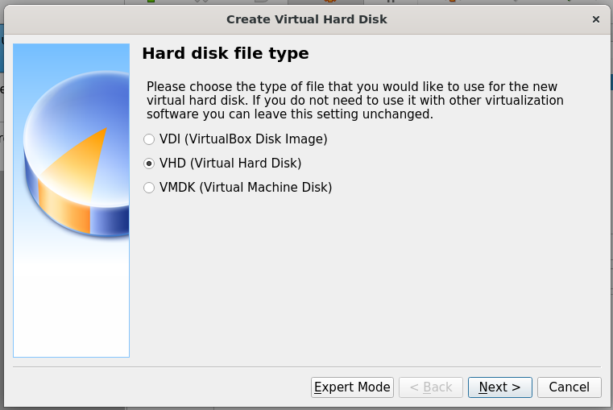

### Storage on physical hard disk

Select: Dynamically allocated

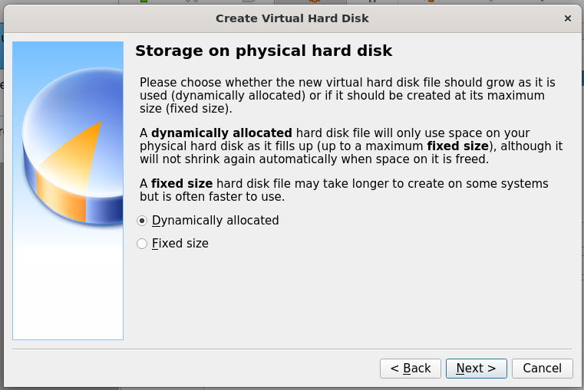

*Next, File location and size …*

### File location and size

Location: /media/nath/4TB/XWM/xwm-mysql/xwm-mysql.vhd

Size: 50 GB

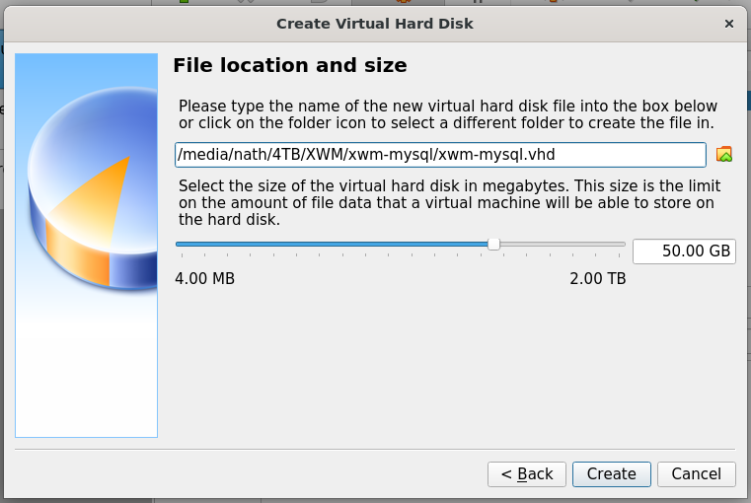

Click: Create *(above)*

The virtual machine xwm-mysql

is displayed in the left column Virtual Box.

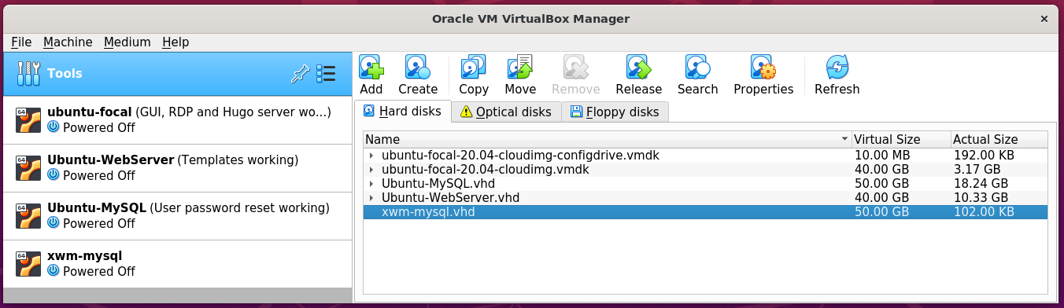

*Next, Install Ubuntu …*

## Install Ubuntu

Open Virtual Box on the host server Ubuntu-LAMP

In the left column

right click the virtual machine xwm-mysql

and select Settings

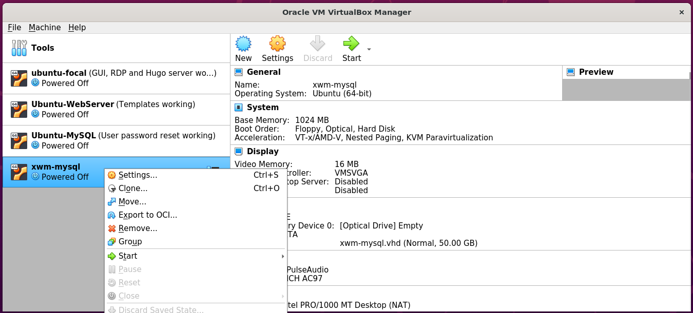

In the left column of Settings

select Storage

then in the middle panel

select Controller: IDE

on the right

select Choose a disk file

and select the downloaded Ubuntu installer

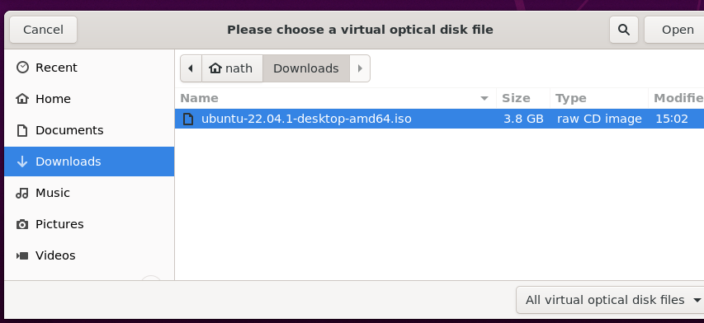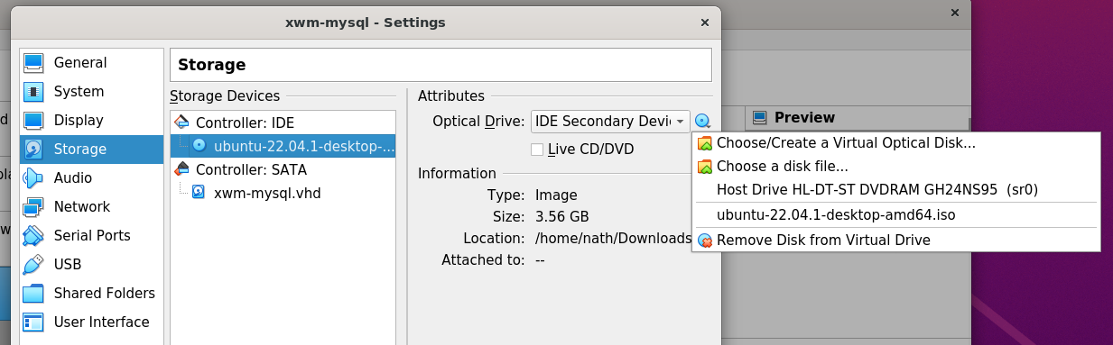

Now that installation iso has been selected

as the virtual machines CD

When the VMS starts-up it will install Ubuntu.

Start the virtual machine xwm-mysql

By clicking Start > Normal Start

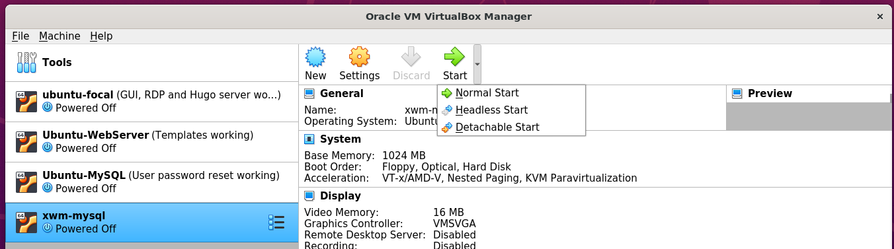

When the boot options are displayed

select: Try or install Ubuntu

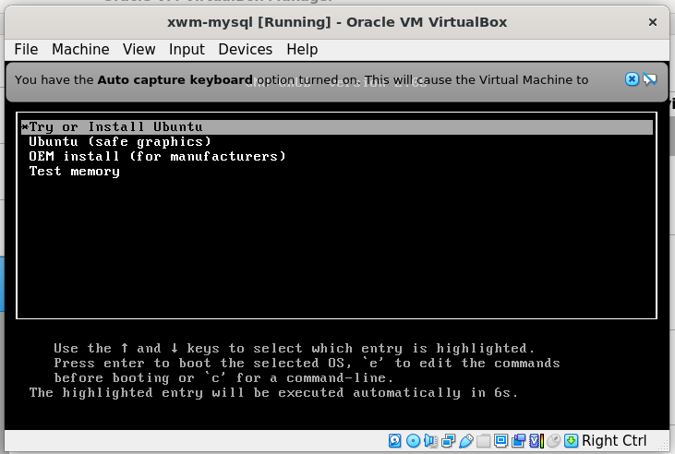

Follow the installation prompts to install Ubuntu

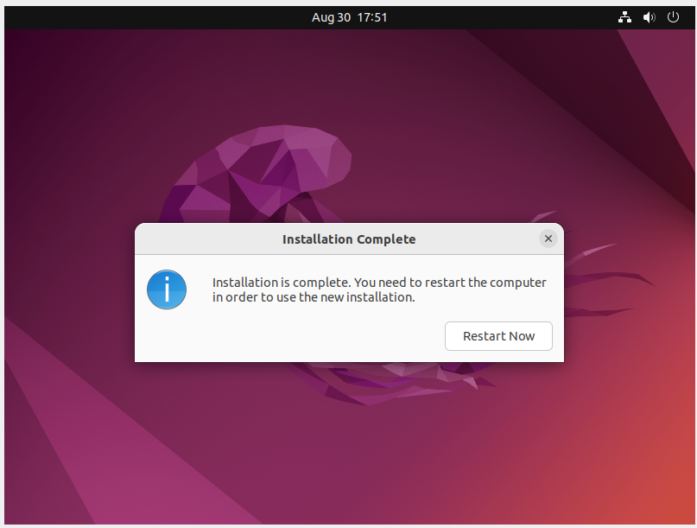

Shut down xwm-mysql

remove the installation iso

then restart the vm

to complete the installation.

*Next, create a snapshot …*

## Create a Virtual Box snapshot

Once the installation completes

shutdown the virtual machine

and create a snapshot of xwm-mysql

Create a snapshot

of the newly installed virtual machine xwm-mysql

In the left menu of Virtual Box

click xwm-mysql’s settings icon *(the waffle)*

and click Snapshots

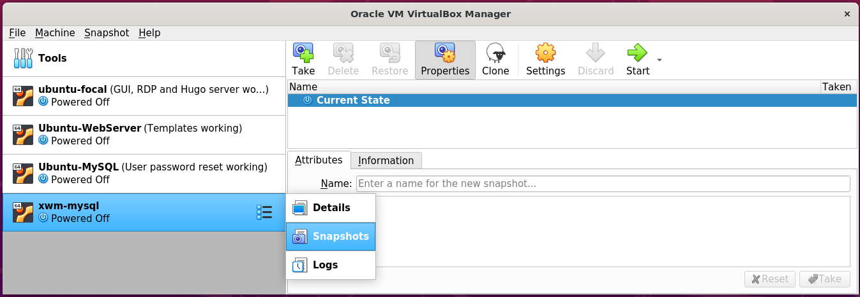

Then on the right, click the Take icon.

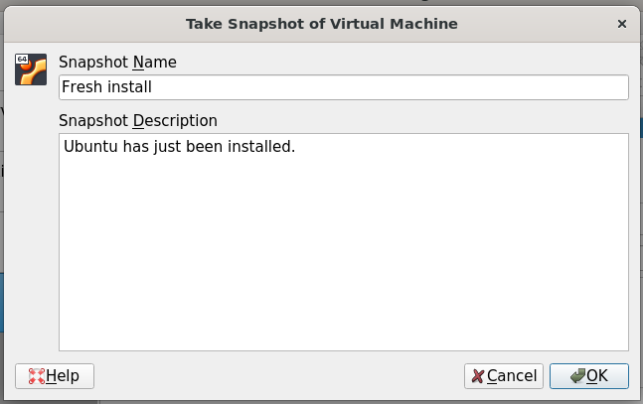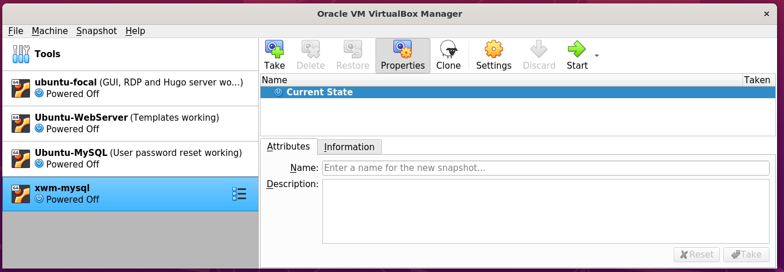

## Bridge the network connection

xwm-mysql is currently on it’s on virtual network.

To allow it to communicate with other devices on the network

right click xwm-mysql from Virtual Box’s left menu

and select settings

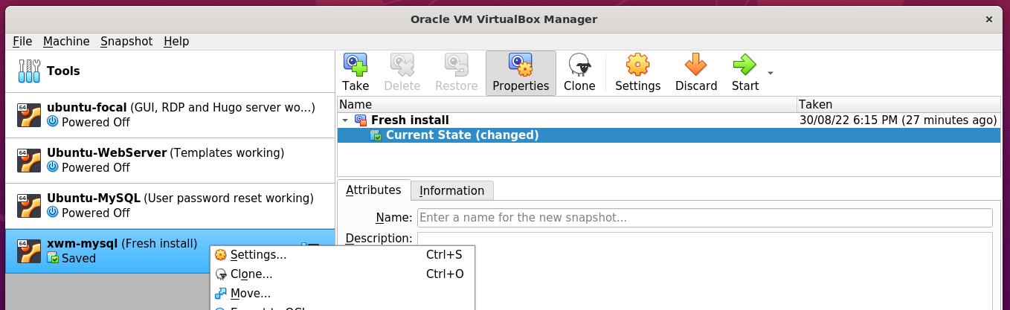

In Setting’s left menu

select Network

Set ‘Attached to’ to: Bridged-Adapter

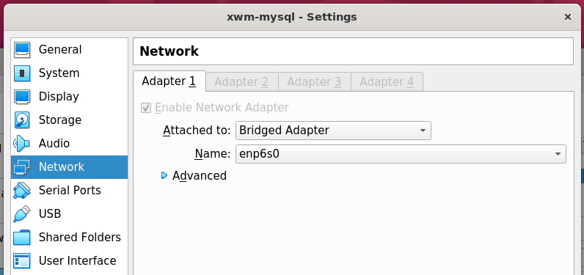

## Install deja-dup and do a backup

https://www.howtoinstall.me/ubuntu/18-04/deja-dup/

In terminal, run the following command:

sudo apt update

sudo apt install deja-dup

#### Example – Install deja dup

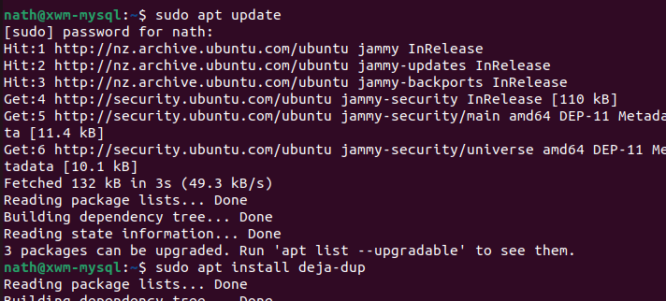

Once installed search for Backup

from Ubuntu’s Show Applications *(Start)* menu.

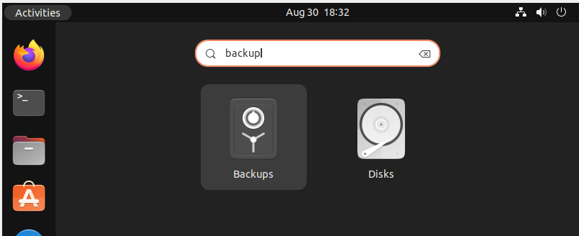

Click Create My First Backup

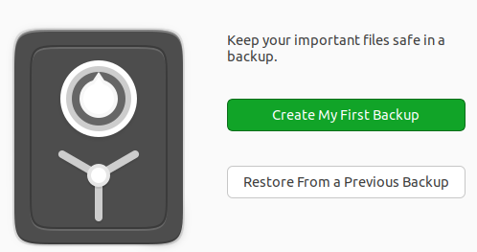

For the meantime, leave the default setting of my home folder: Home(nath)

as folders to be backed up.

In the future I will also need to back up the MySQL folders.

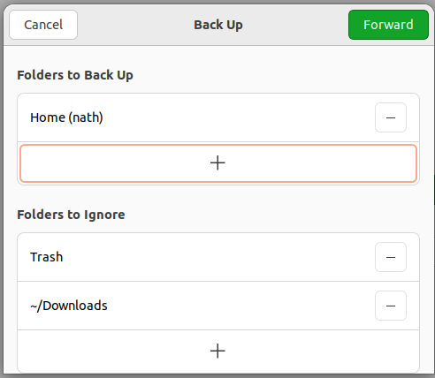

*Next, Select the storage location …*

Save backups to the USB drive

connected to the host machine Ubuntu-LAMP

Storage Location: Network Server

Network Location: smb://ubuntu-lamp.local/ vm_backups

Folder xwm-mysql

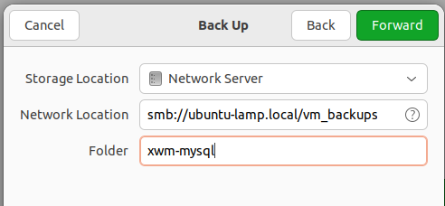

Authenticate as the user nath

on Ubuntu-LAMP

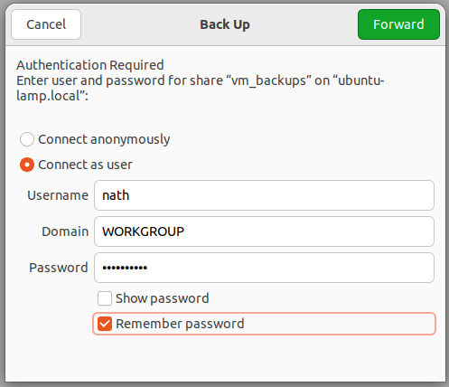

Create the password for the backup

for the virtual machine xwm-mysql

and select Remember password

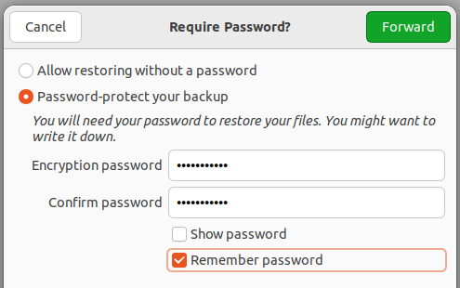

Once the backup completes

select Back up automatically

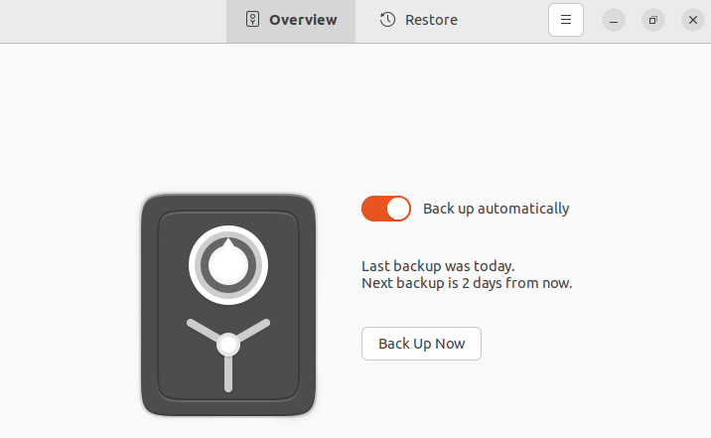

Take a snapshot of the virtual machine

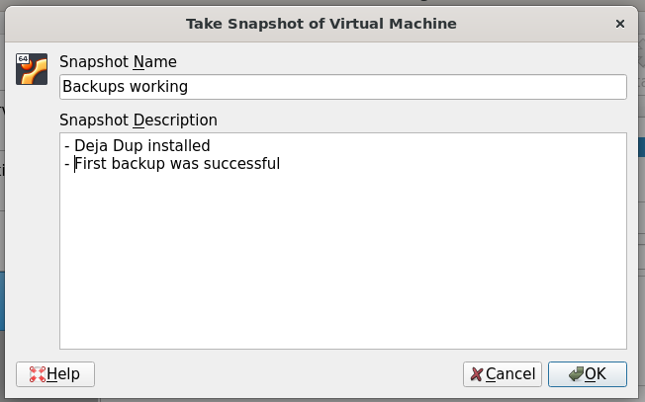

## Remote desktop using xRDP

Install xRDP *(and ‘snake oil’)*

then restart the server

sudo apt update

sudo apt -y install xrdp

sudo adduser xrdp ssl-cert

sudo systemctl restart xrdp

#### Example – install xRDP

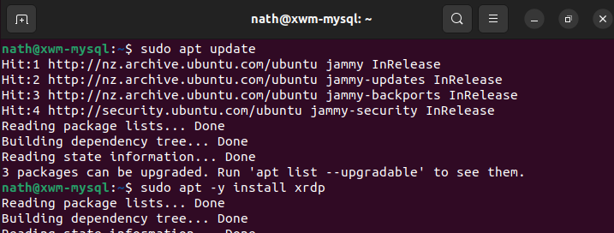

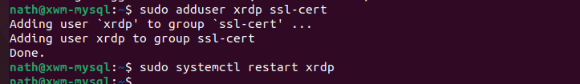

### Configure the firewall for RDP

To allow RDP connections, run the command:

sudo ufw allow 3389

sudo ufw enable

sudo ufw status

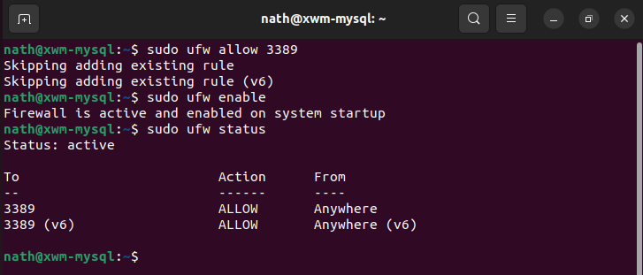

To allow the settings to refresh, restart xwm-mysql

*Next, Remote onto xwm-mysql …*

## Remote onto xwm-mysql

From Naths-Legion

Remote-desktop onto xwm-mysql

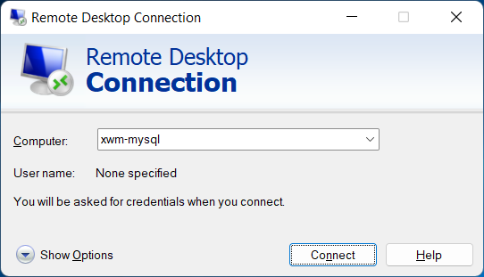

After accepting the connection certificate

xwm-mysql can be seen via remote desktop.

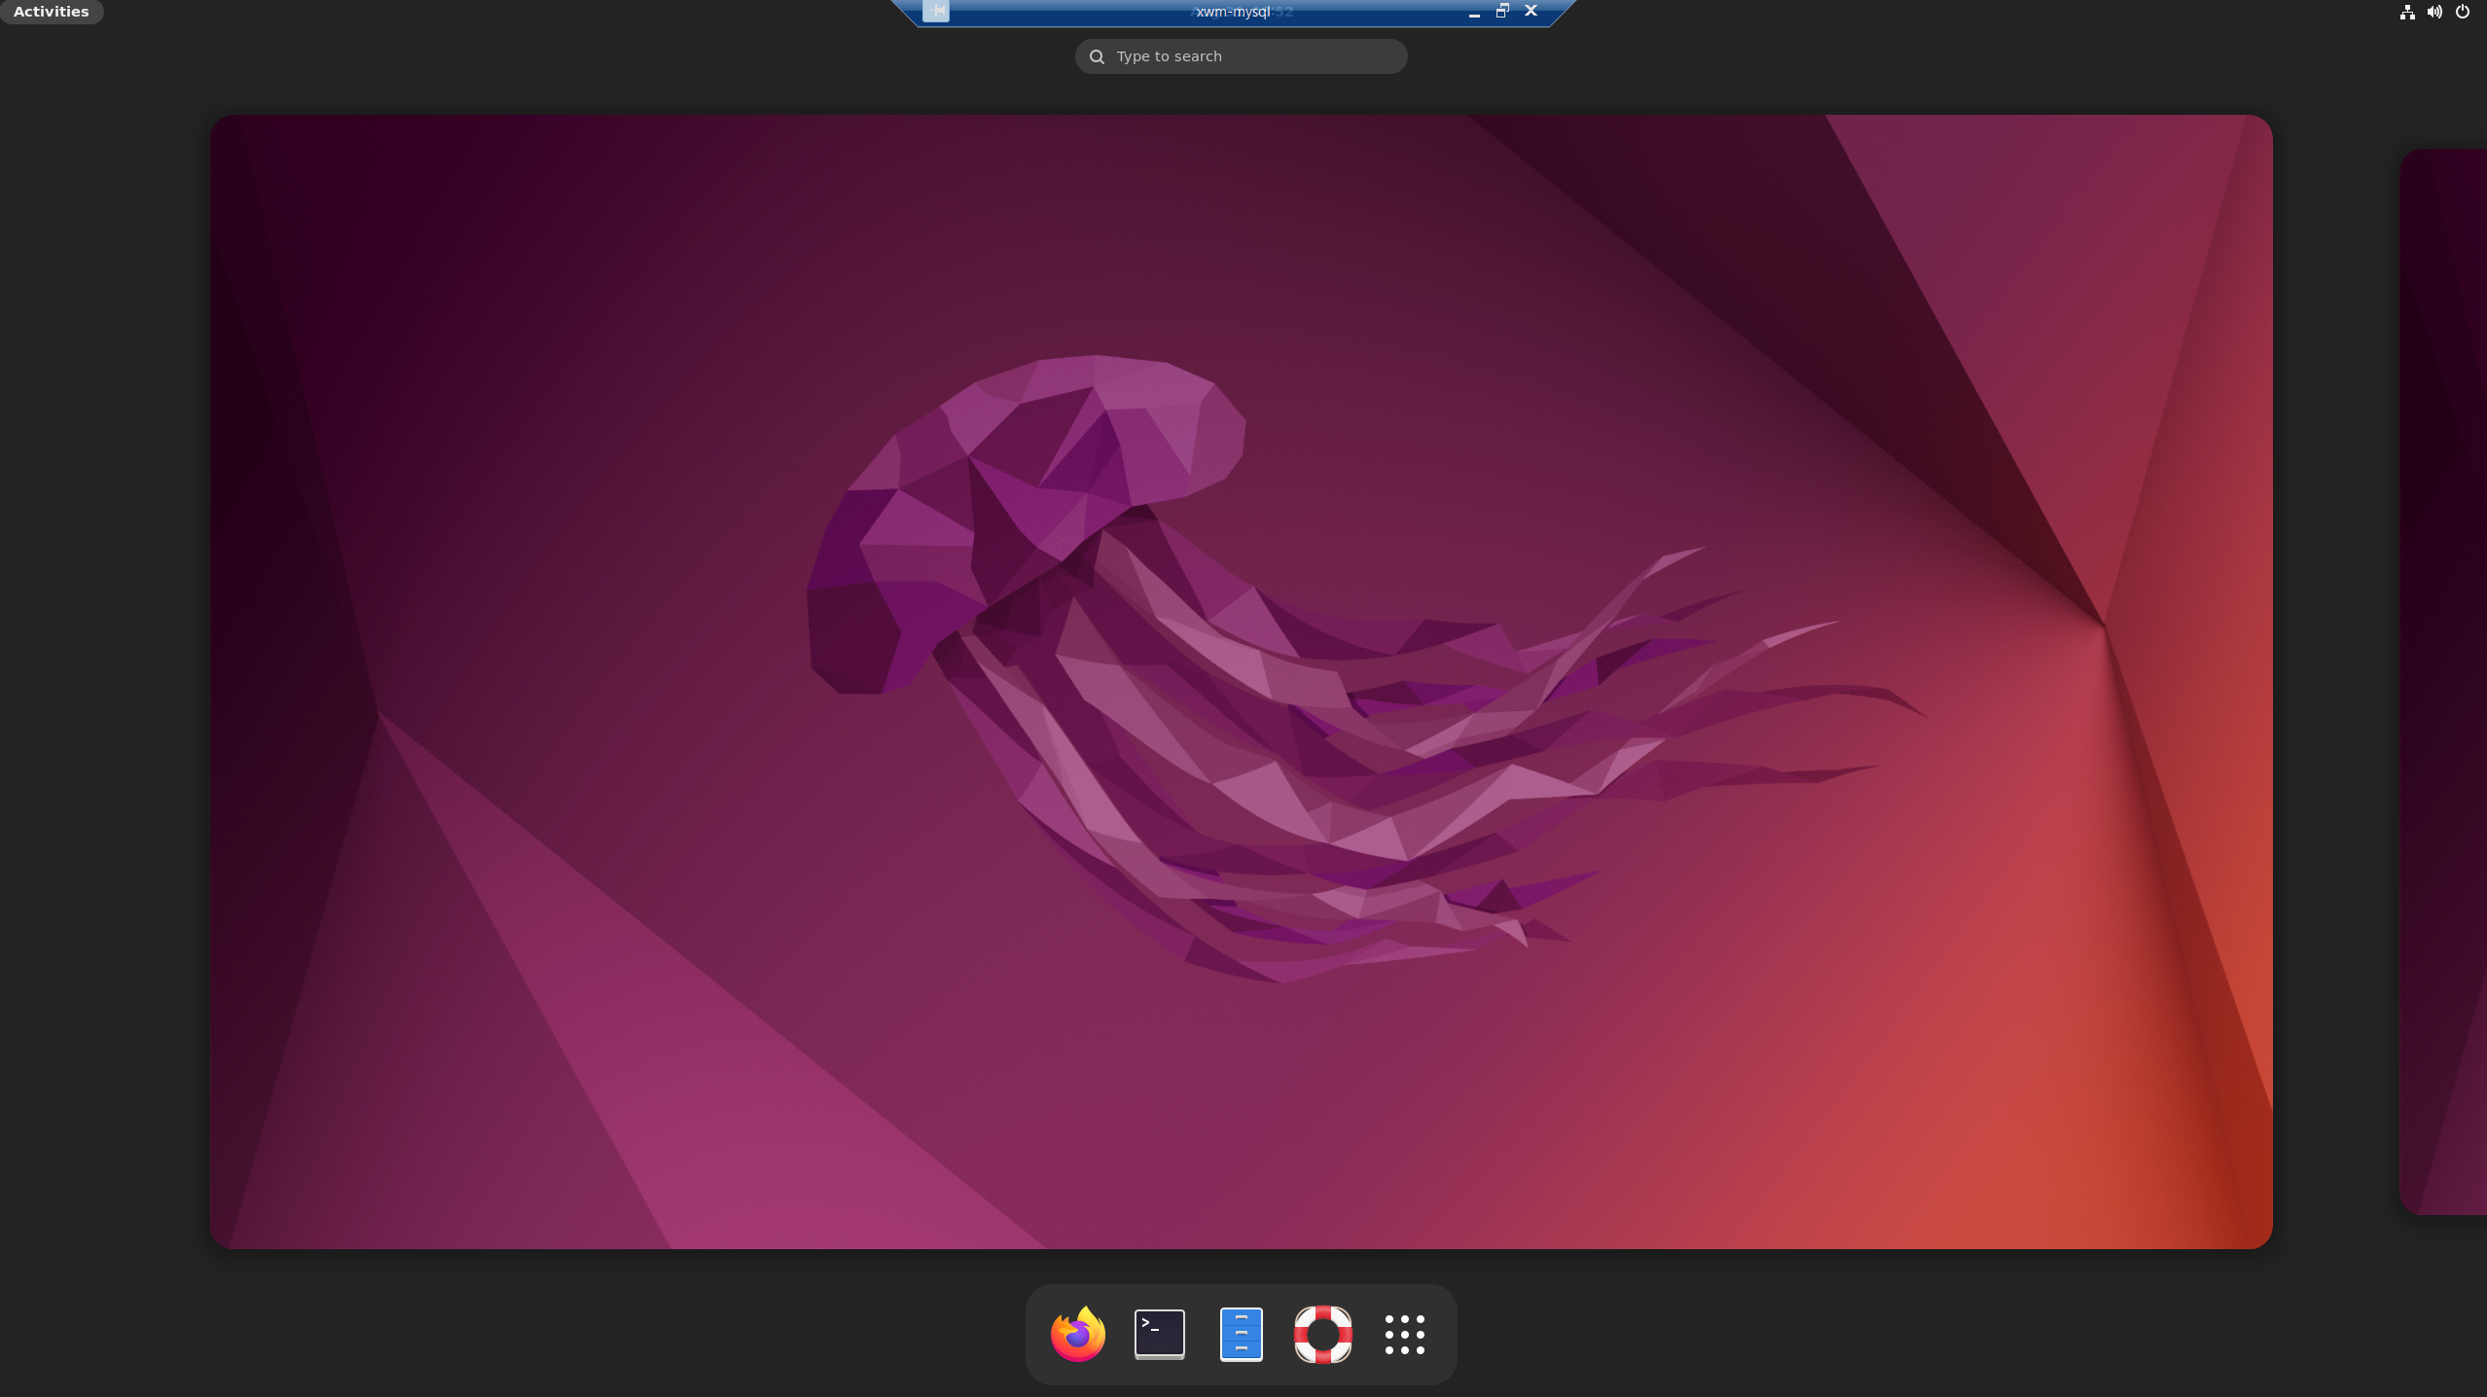

# Install MySQL

To install MySQL run the following command

sudo apt update

sudo apt install mysql-server

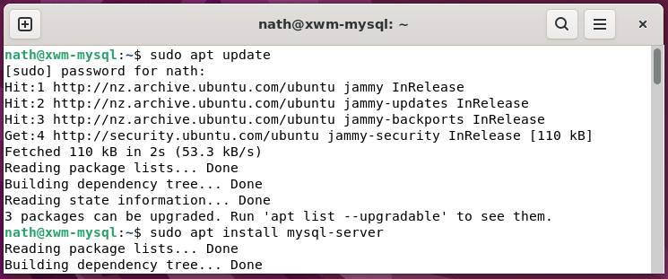

Check MySQL’s status, by running the command

sudo service mysql status

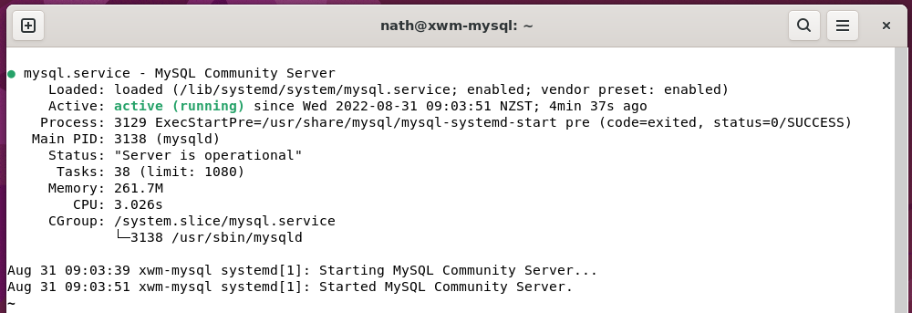

If the server is not running correctly

the following command will start it:

sudo service mysql restart

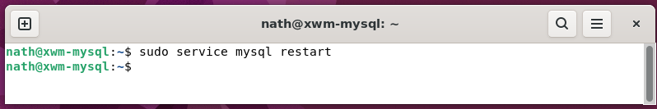

*Next, Create a MySQL user …*

# Create a new user on ‘xwm-mysql’

Open MySQL, by running the command

sudo mysql

#### Example – Run MySQL

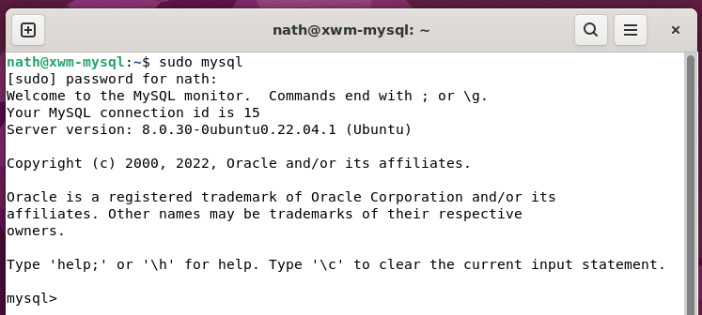

#### Example – Add a user to MySQL

In MySQL, create the admin user

by running the command

CREATE USER '***username***'@'%' IDENTIFIED BY '***password***';

GRANT ALL PRIVILEGES ON *.* TO '***username***'@'%' WITH GRANT OPTION;

### Login to MySQL as admin

To login to MySQL as admin

run the following command

mysql -h localhost -u root -p

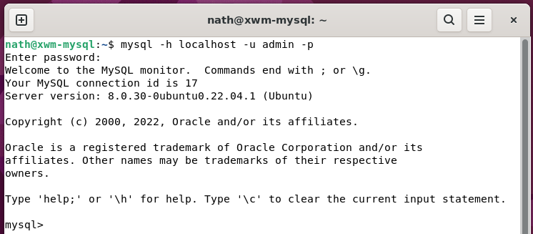

As everything is working up to this point

it’s great time to backup xwm-mysql

and take a Virtual Box snapshot.

